**Aggregation**

Aggregation refers to the process by which entities are combined to form a single meaningful entity. The specific entities are combined because they do not make sense on their own. To establish a single entity, aggregation creates a relationship that combines these entities. The resulting entity makes sense because it enables the system to function well.

* **TYPES OF DATA AGGREGATION:**

**Sum**

This tool is used for combining the various specified data for creating a total value.

**Average**

The average value of the particular data is fully computed by this command.

**Max**

It is used for showing the highest value for every category in the database management system.

**Min**

It is used for providing the lowest value for every category in the database management system.

**Count**

The total number of data entries is counted for all the categories available in the database management system.

**Example:**

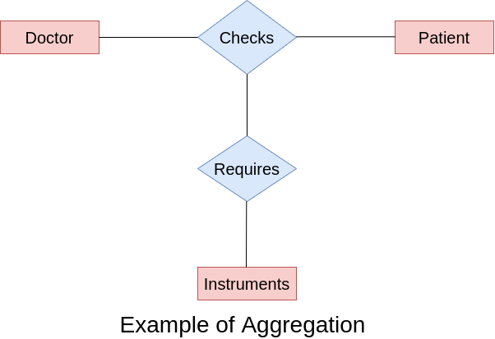

Let's suppose there are two entities in the Hospital database, whose names are Doctor and Patient.

These two entities are related through a relationship set Checks.

A doctor who checks the patients must require the instruments or tools. So there will be another relationship set Instruments.

We need to connect the relationship set requires to an entity set Instruments and relationship set Checks. But, we can connect only entity set to a relationship set.

One relationship set cannot be related to another relationship set; for this, we need the aggregation concept. So, aggregation is needed when you express a relationship set with another relationship set.